|  |  |  |  |
| --- | --- | --- | --- |
| 1 | Name of project | *Tunza Punda Inua Jamii* Donkey advocacy project | |
| 2 | Background and write up | ***Start date***  2019 |  |
| ***County/ sub county/ Ward-Schemes***  Siaya County/Bondo and Rarieda sub-counties/Migwena and uyoma  Kisumu County/Nyakach and Seme sub-counties/ | |
| 3 | Target | By June 2021, Donkey welfare policies formulated and adopted hence improved health and strengthened livelihoods of donkeys | |
| 4 | Number of beneficiaries |  | |
| 7 | Achievements |  | |

**Background Information**

STIPA through support from BROOKE EA under the *Tunza Punda Inua Jamii* project aims to achieve a thriving Donkey welfare and strengthened livelihoods of donkey owning communities that we work with. Working donkeys in the two counties. 300 Donkey owners and users in the two counties 1800 Indirect beneficiaries (Youth, Juakali artisans, women and children. This is planned to be realized through mobilizing the youth, (men and women) in rural agricultural and peri-urban areas, and to train them on proper use and care of donkeys for optimum working efficiency and financial returns. Capacity building of donkey owners, to facilitate prompt veterinary services for implementation of a community-based livestock health insurance scheme run by the donkey owner groups. STIPA continues working the governments of Kisumu and Siaya Counties to support the donkey owner’s association and develop a legal framework of policies for protection and care of donkeys. Community involved advocacy against donkey theft, slaughter and unethical welfare practices partnership with governments, local authorities, community leaders, donkey owners and other stakeholders in advocacy against the slaughter of donkeys DHT (Donkey Hide Trade). Contribution to the ban of donkey slaughter in the abattoir in Kenya. Introduction of the CBLHF concept to donkey owning households. Training and adoption of livelihood activities among the beneficiaries.

**PHOTO GALLERY**

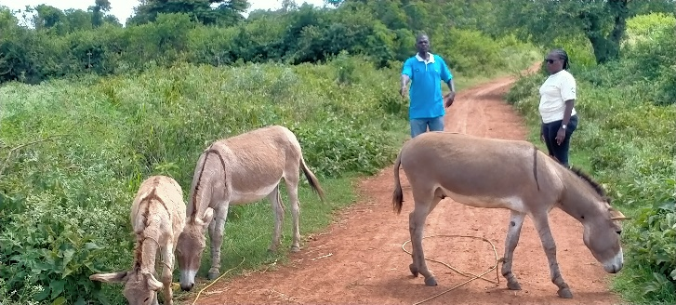 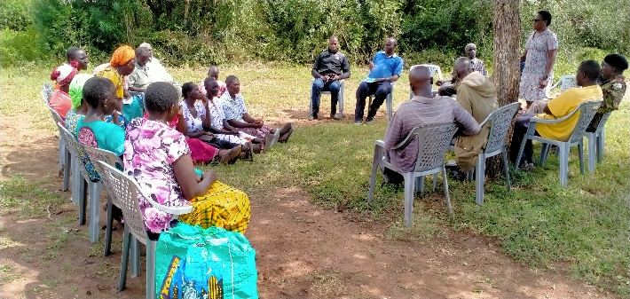

Figure 2: Damaris Adhiambo, STIPA P.O engaging stakeholders & donkey owners on issues of security and donkey welfare during a sensitization session in Migwena on 17th September 2020.

Figure 1: Damaris Adhiambo, STIPA P.O Siaya conversing with a donkey owner in Sakwa, Bondo during the baseline survey on 6th August 2020.

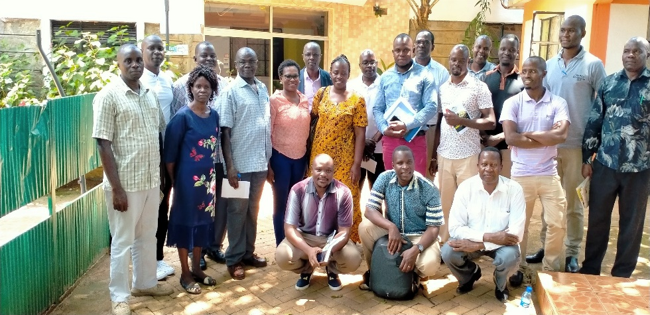Figure 3: A group photo of STIPA’s project implementation team including other stakeholders, Kisumu and Siaya county government officials.

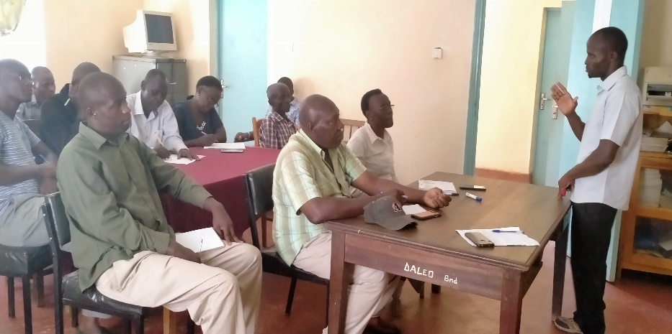 Figure 4: SCVO Kisumu Morvan, addressing leaders of Community Action Groups, donkey owners and stakeholders in one forum Bondo for formal engagement on 14th August 2020.